How to create a Virtual Machine in Azure

**Create a virtual machine**

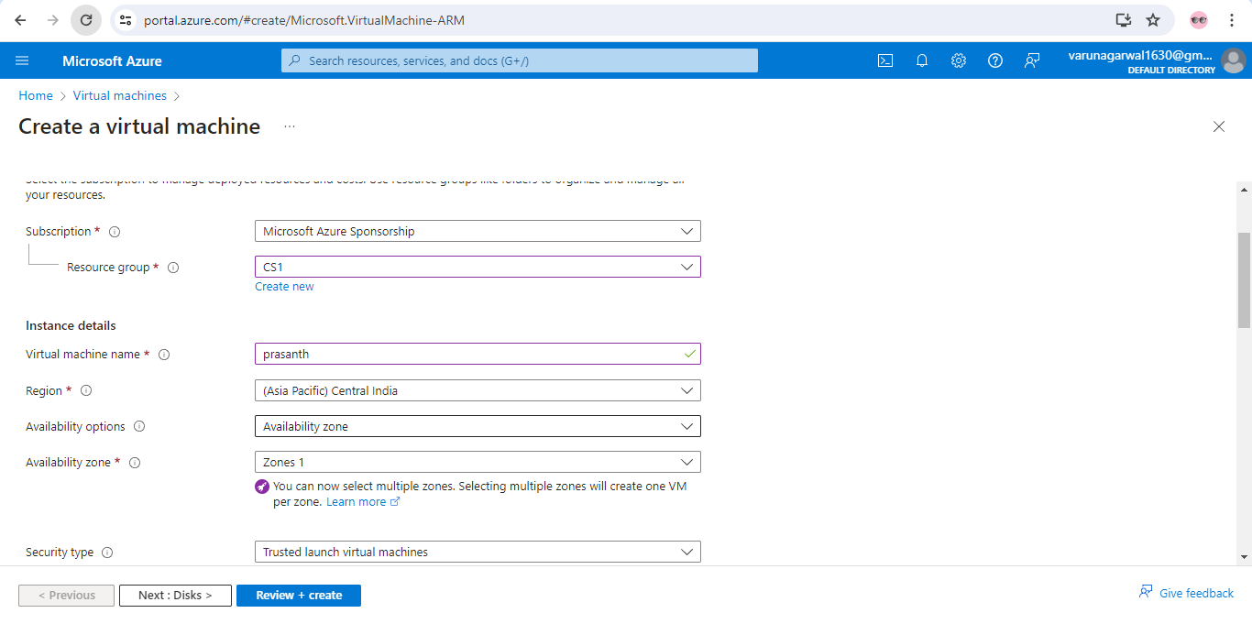

Give the virtual machine name, Region, availability zone .

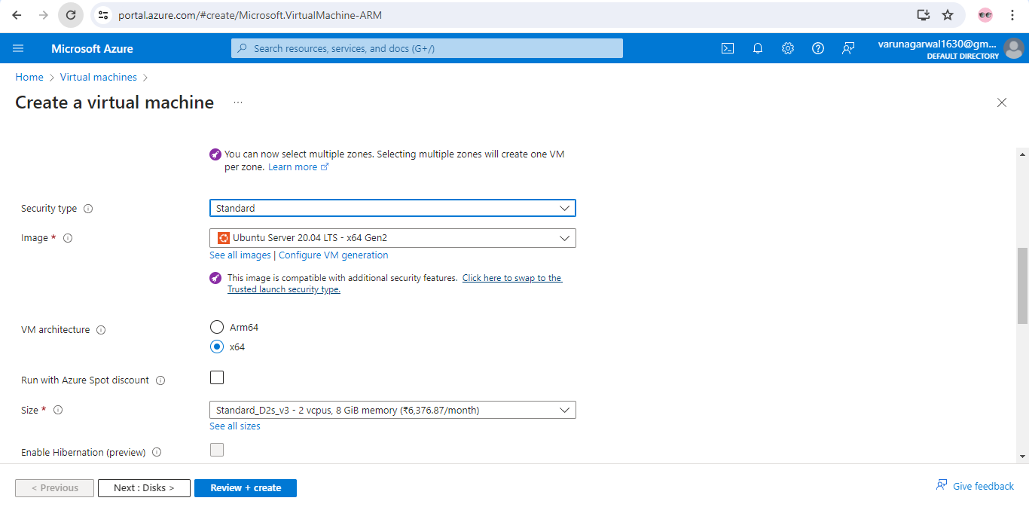

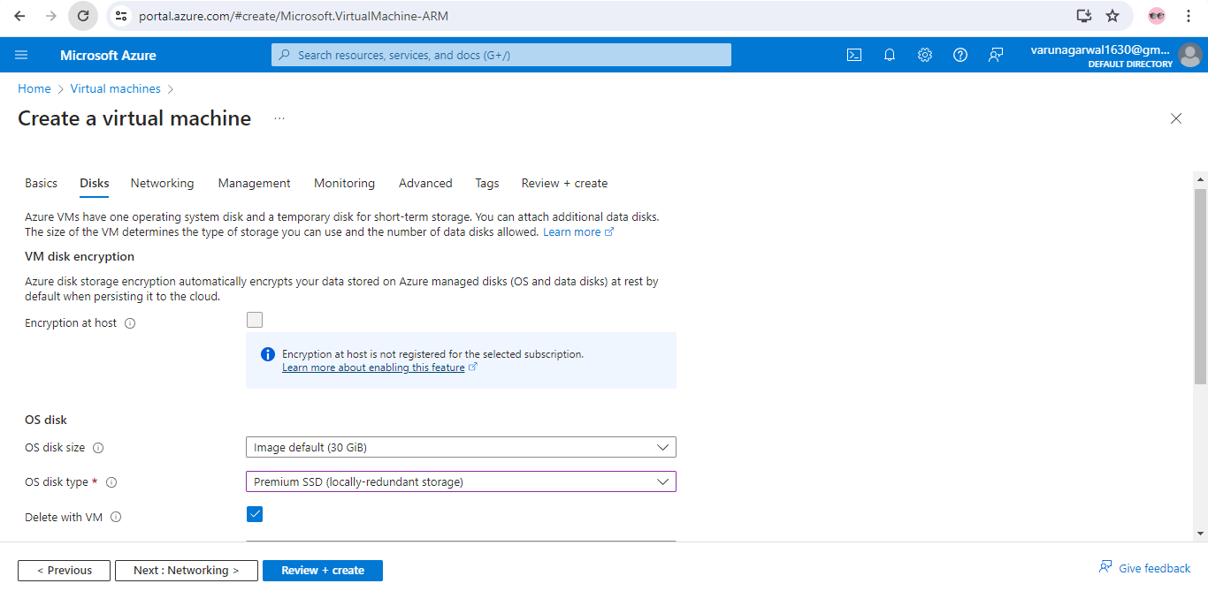

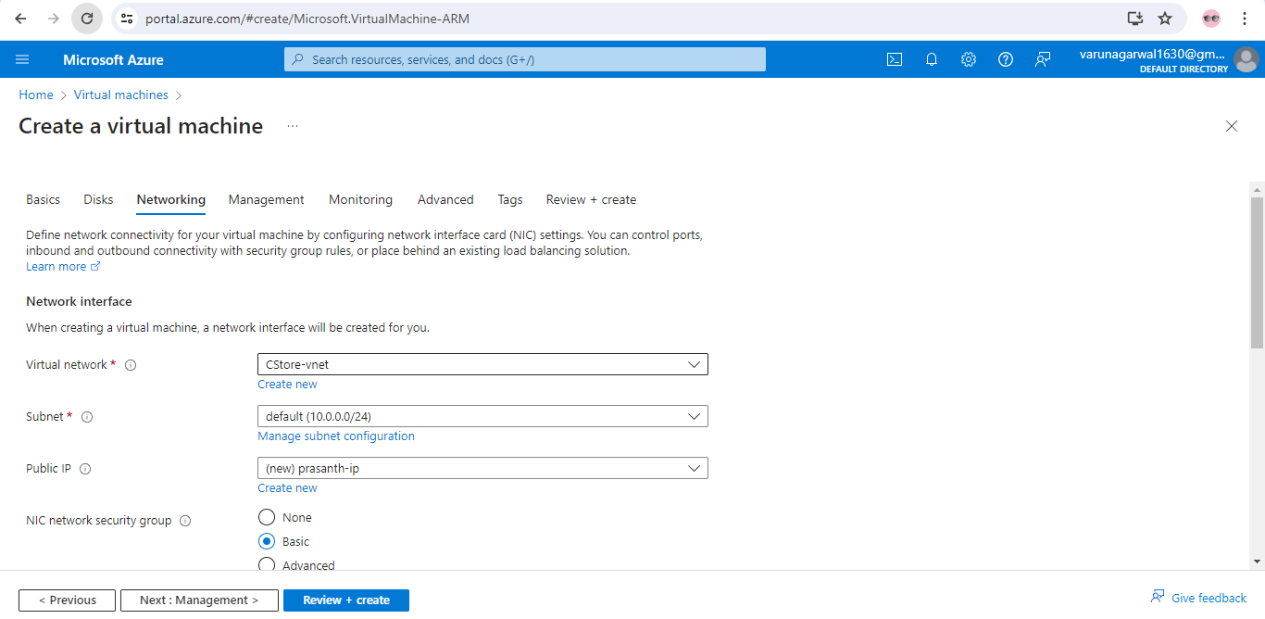

After management, Monitoring, advanced, tags and review the all and create an virtual machine.

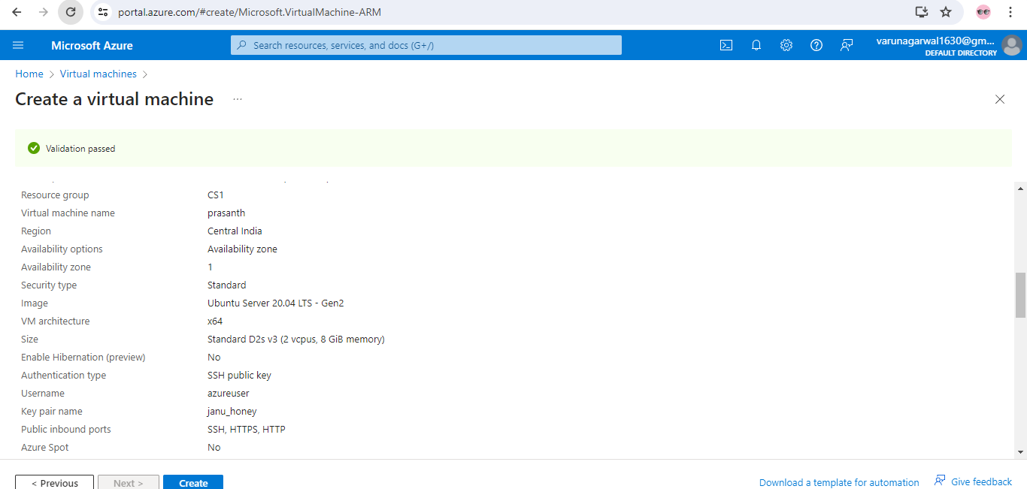

After review and create after deployment in progress is success

Go back to resource and check virtual machine is created

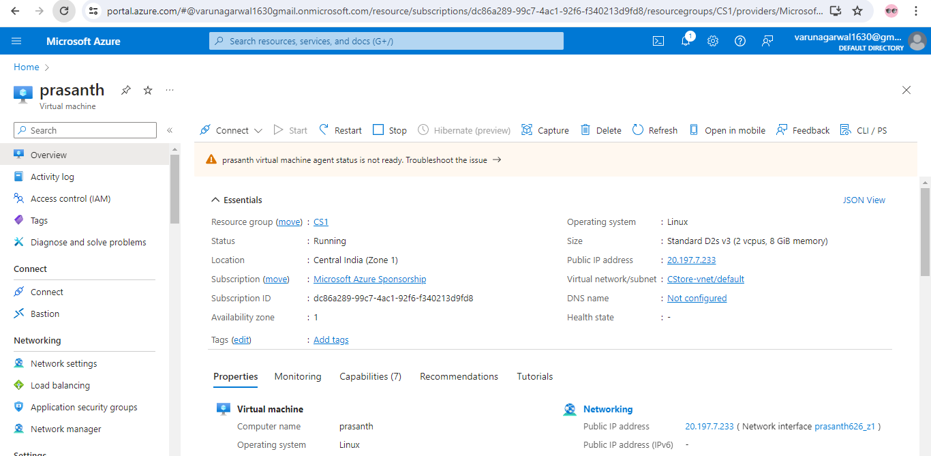

How to connect terminal

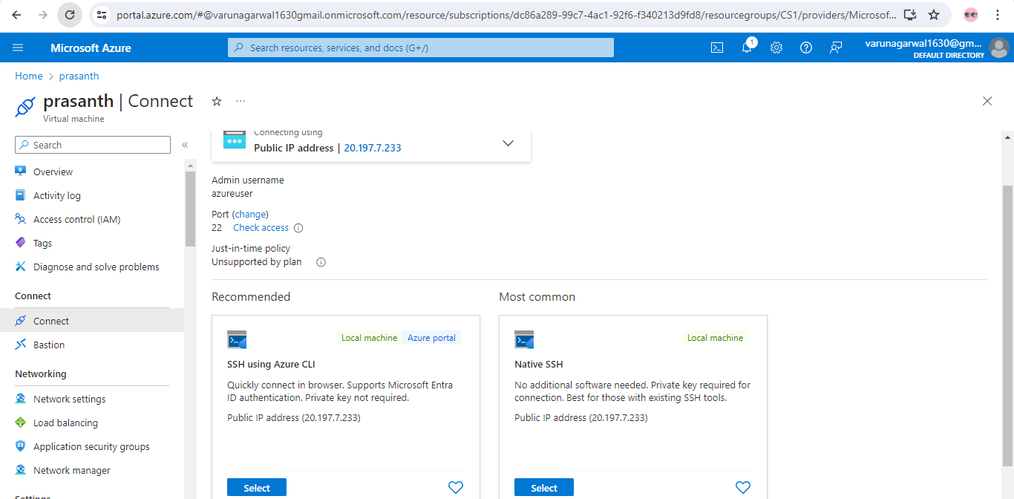

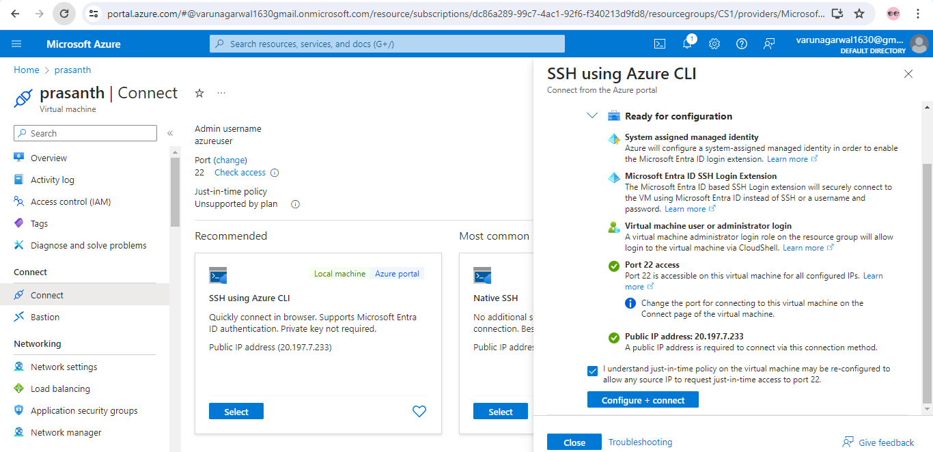

After validation has successfully passed click on configure + connect it will connect to terminal.